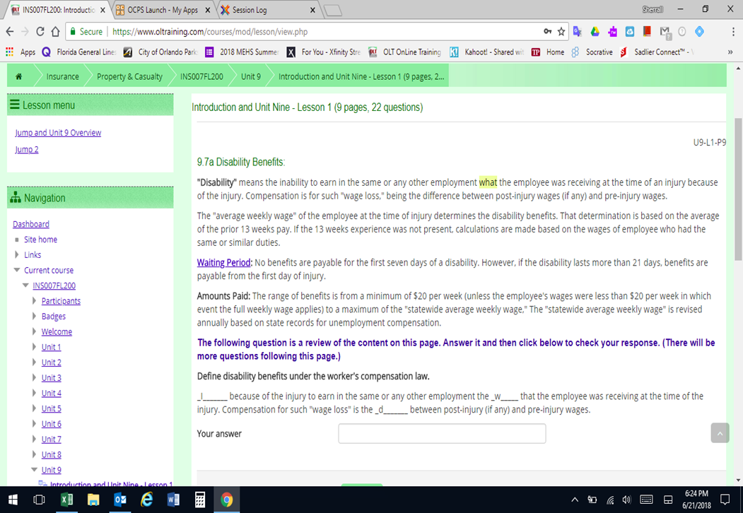

Word should be “inability”

Word should be “that”